

User Manual

**Hi, welcome to FETCH! A web application that allows you to read, review, and rate products. FETCH! Is your number one location for product reviews.**

This user manual will serve as a guide to help you operate our website. Once finished reading this guide, the user should know how to do the following:

1. **Create an account**
2. **Navigate the user profile**
3. **Look at reviews on products with/without creating an account**
4. **Post a review**
5. **Rate reviews on products**
6. **Search a product for reviews.**
7. **Create an Account:**

**In order to post reviews on FETCH! You’ll have to create an account on our website. Note: You don’t have to create an account to view content on our website.**

**Follow these Instructions to create an Account:**

* Simply type in your email address on the user page.



* If an account (email) is not found, our website should prompt you to enter a password to complete your account.

1. **Navigate the user profile**

**Once you’ve created an account on FETCH! You’re ready to navigate through the user profile page.**

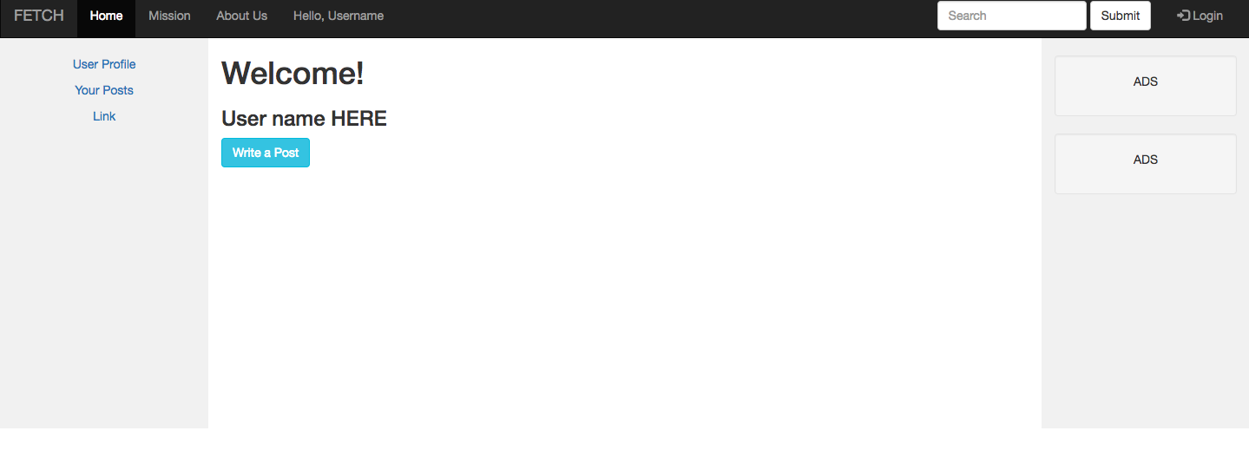

If you click “User Profile” you’ll be brought back to this page.

If you click on “Your Post” you’ll be prompted to a page to view all of the post, you as a user has posted on FETCH!

1. **Look at reviews on products on FETCH!**

**Looking at reviews on products can be beneficial in search of find a product that is right for you. Follow these step to guide in the process of looking at reviews. Note: You don’t have to create an account to view review content on our website.**

* **Visit the the homepage of Fetch.com, which should look like this.**



* **Click on the Fetch logo, and it should guide you to our second main page, which looks like this.**
* 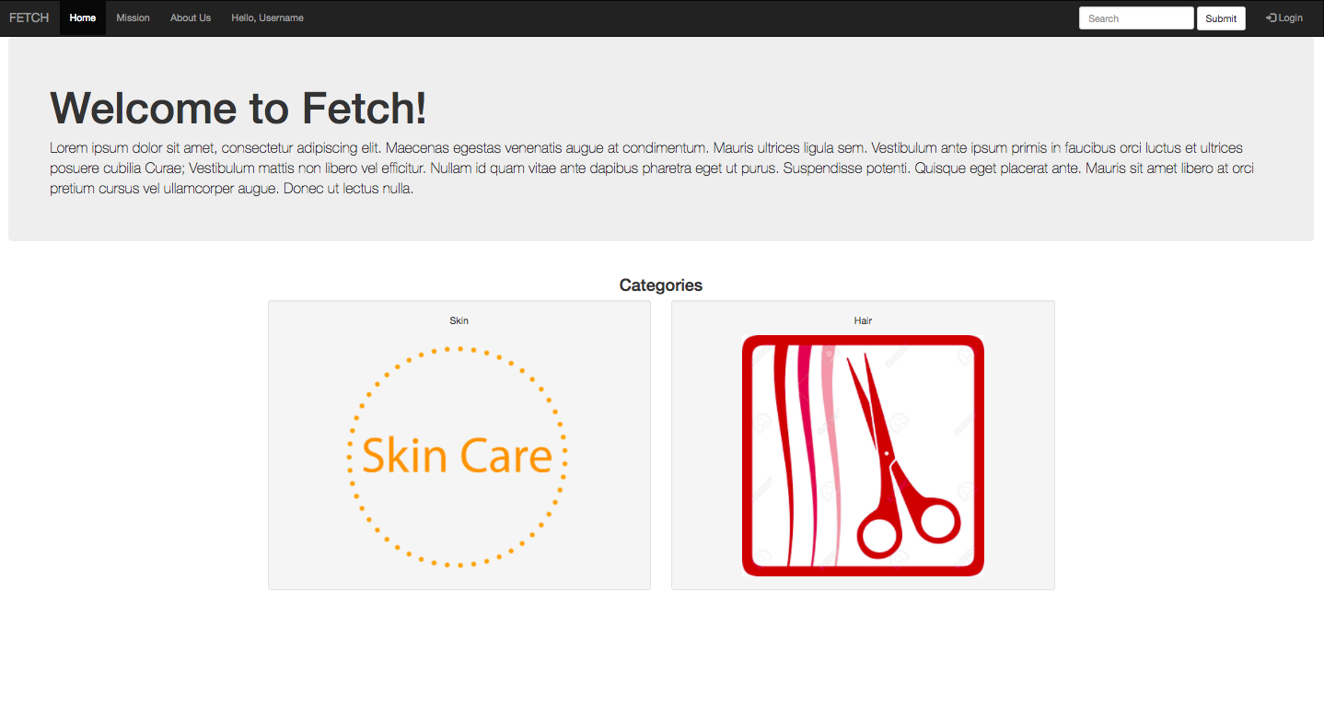**Once here, you’re able to click the category of either skin or hair and looking though the products we have to offer with reviews.**

**NOTE: If you’re logged in as a user, this page will be slightly different and should look like this:**

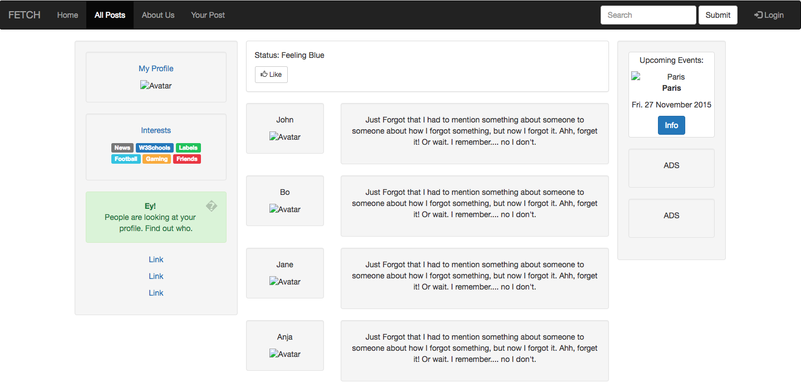

In the middle of the page, you’ll be able to read about recent post on FETCH! Website. To the left of the page, you’re about to see your profile information, followed by advertisements to the left of the page (which will be developed in future versions.

* If you would like to get back to our second main page, simply click the “home” tab in the top left hand corner, next to our logo.



1. **Post a review on FETCH!**

**In order to post reviews on FETCH! You’ll have to create an account on our website. Note: You don’t have to create an account to view content on our website.**

**Follow these instructions to post a review:**

* **On the Main page, click on the tab in the top left folder, “hello username”.**

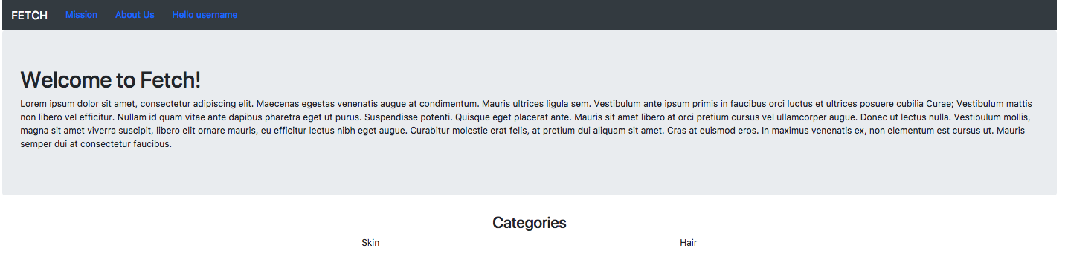

* **Once you click on “hello username” it should prompt you to log in. If you have you have not logged in already, please do so. Note: You need to create an account in order to post a review.**
* **After you log-in you should be prompted to the profile page.**



**Click on the blue button “Write a Post” in order to write a review on a product!**

1. **Rate reviews on products**

* In order to rate a review on our website, you don’t have to be a member. Simply, look at the review of product of your choice. Once, that review is clicked, it should pop open on the screen, there should be a scale at the bottom of the review ranging from 1 to 5. 1 being the lowest and 5 being the highest.

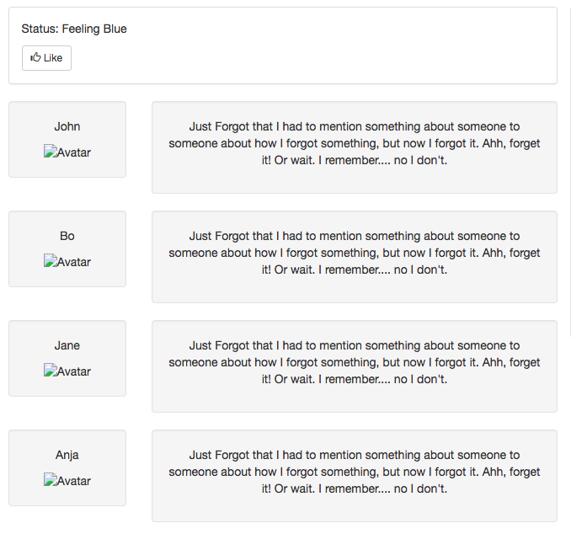

As mentioned once you click on a review, you’ll be about to rate the review.

1. **Search a product to look at reviews**

**To search products on FETCH! Just visit any of the search bars on our website and search a product of your choice. Note: FETCH! Is still in development and we only have a limited amount of products in out database, but we do plan on increasing the items in the future.**

* Our main search bar is located in the top right hand corner of the main navigation bar. Simply search a product name for reviews or type in one of our reregistered tags.

../Screen%20Shot%202017-12-15%20at%208.16.07%20PM.png